**D2 – discuss the impact that file format, compression techniques, image resolution and colour depth have on file size and image quality**

**Introduction**

In this assignment, I will be explaining the impact of file format, compression techniques, image resolution and colour depth have on file size and image quality. Each of ‘file size’ and ‘image quality’ has been explaining in one section of it.

**Image resolution (File Size and Image Quality)**

Image resolution is the detail the image holds. This means any program can help you resize the image in any shape or form. The user can zoom into the image by following the steps:

**IMAGE 🡪 IMAGE SIZE OR** HOLD THE KEYS **ALT+ CTRL+ I**

By following these steps, you can change the resolution of the image. If you want to change the resolution, it measures it dots per inch (DPI). It is important if you want to change the resolution of the image as you can go into detail, take that picture, and add it somewhere. For example, if you use zoom into a house and you zoom into the window, you can use that for another picture and add it there.

**BEFORE AFTER**

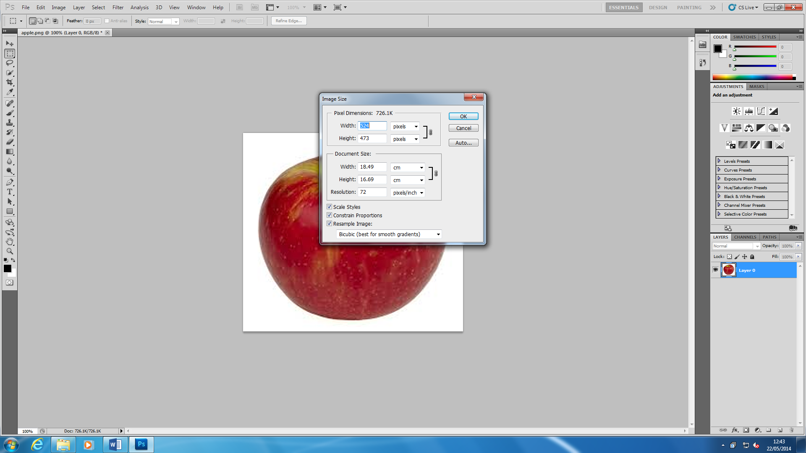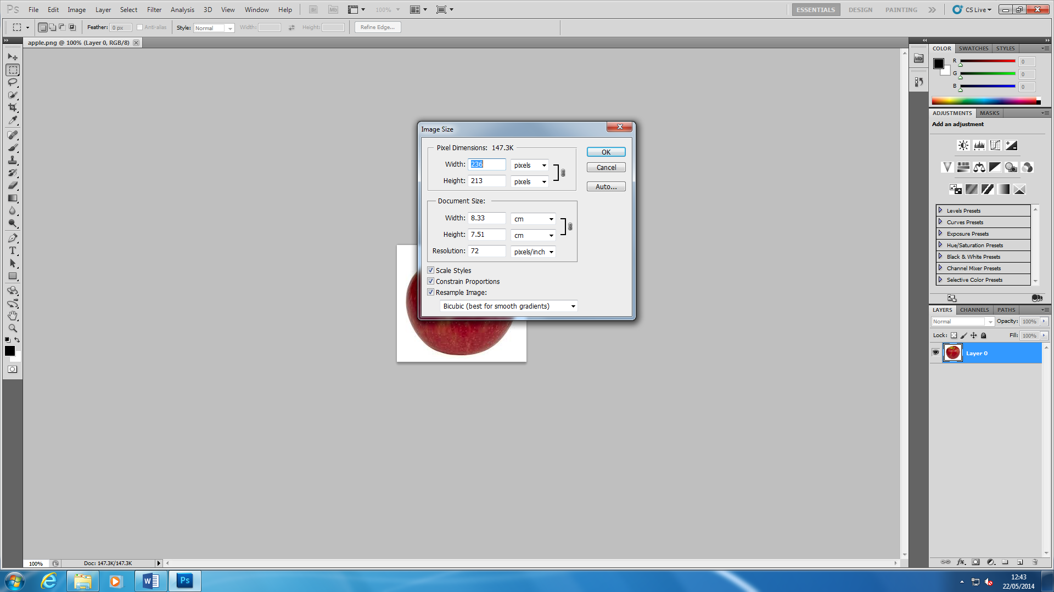

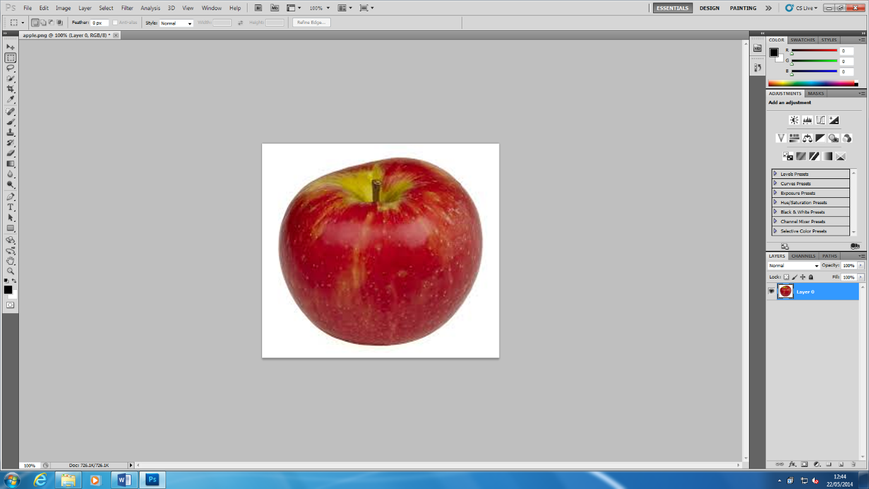These two images came from Adobe Photoshop and I changed the resolution of the image. ‘Before’ image is all the same. I changed it by typing into the ‘Width’ box ‘524’ to zoom the image. If you really want to zoom right into the image, you can type in a higher number for the image resolution to be high. However, if you do increase the image resolution, the quality of the image loses. The higher the image resolution, the more the quality of the image loses. The image below was the result once I had changed the image resolution. The file size will have an effect of the image resolution. Image resolution is measured in DPI (Dots per Inch) and if the quality of the image is increased, the file size will increase. It matters if the quality of the image is quality or not.

**File Format** (**File Size and Image Quality)**

A file format is a standard code that is encoded for storage in a computer file. Each standard code are different to each other such as BMP, GIF. They are completely different from each other and have different storage available. They are many file formats and the image below shows how many they could be. They could be more but these are a few. They are the type that can be saved. For example, for Adobe Photoshop, once you have created something, you can save it as a JPEG so you can use it to show others even though you do not have Adobe Photoshop on another system. The image quality stays the same, but the file size of it decreases. It compresses all together for it.

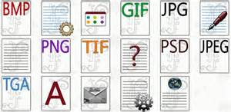

**Compression Techniques (Image quality and File size)**

Compression techniques are used in files or image that reduce quality or does not reduce quality when used. The file size changes dramatically. If it is 3000KB, it will change to around 49KB. There is a big difference between the two. Nit does not matter which two, either lossy or lossless, they both are going to change. The two types are called lossy and lossless compression.

**Lossy:**

Lossy compression is when you extract certain amount of information within a file that are not needed. Lossy compression is mostly used in likes of ‘BMP’ (Bitmap Image File). Any image loses quality depending on the compression (low, medium or high). This is used in media such as images. Another file that uses lossy is ‘JPEG’.

**Lossless:**

Lossless is a type of compression which doesn’t lose any data when reducing the amount of data. Lossless clamps all information into a 'more modest packs' or into a littler document measure by inside shorting the information. Case in point if a record size was initially 2(MB) lossless squeezing can decrease the document size into and a large portion of 1(MB) however anyway it relies on upon the document broadening on the off chance that it might be compacted effectively. Lossless packing is exceptionally valuable when using up space or attempting to spare. A great illustration of lossless layering programming might be 'WinZip'. WinZip utilizes lossless squeezing which packs things like projects features, writings, pictures.

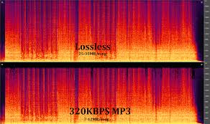

**Colour depth**

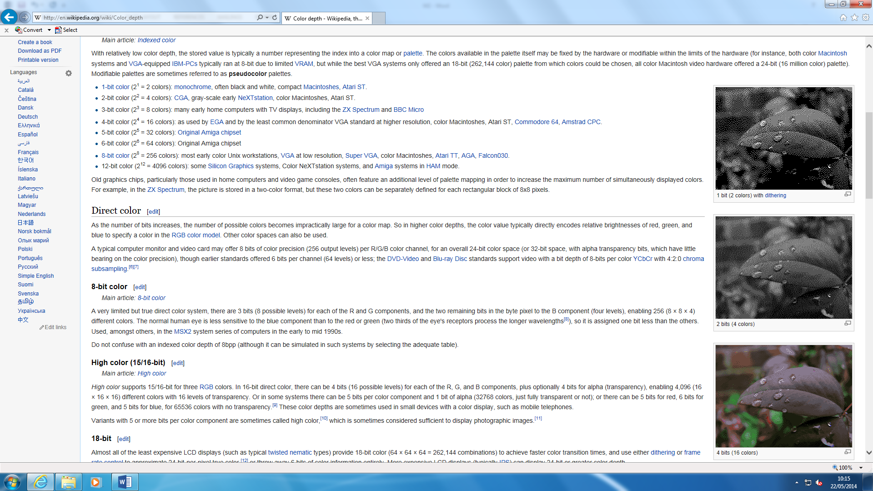Colour depth, also known as bit depth, is either the ‘bit’ used to specify the colour used in a single pixel. The colour depth ranges from 1-bit monochrome to 48-bit deep colour. An image can be present and it can be used to change the colour state e.g. all of the picture would be grey. The depth could be that the ‘grey’ could go ‘light’ or ‘dark’ grey. These are called ‘bits’.

As you can see figure 1.1, it demonstrates the colours that are used on the picture. These range from 1-4 bits and it changes the whole picture by its colour depth. 1 bit is the darkest out of all of them and it goes lighter as the bits increase. Each bit has specific colours that have been inserted. 1 bit has 2 colours. As the bit increases (+1), the colours double. The pattern below shows the how it all works.

* 1 bit = 2 colours
* 2 bit = 4 colours
* 3 bit = 8 colours
* 4 bit = 16 colours

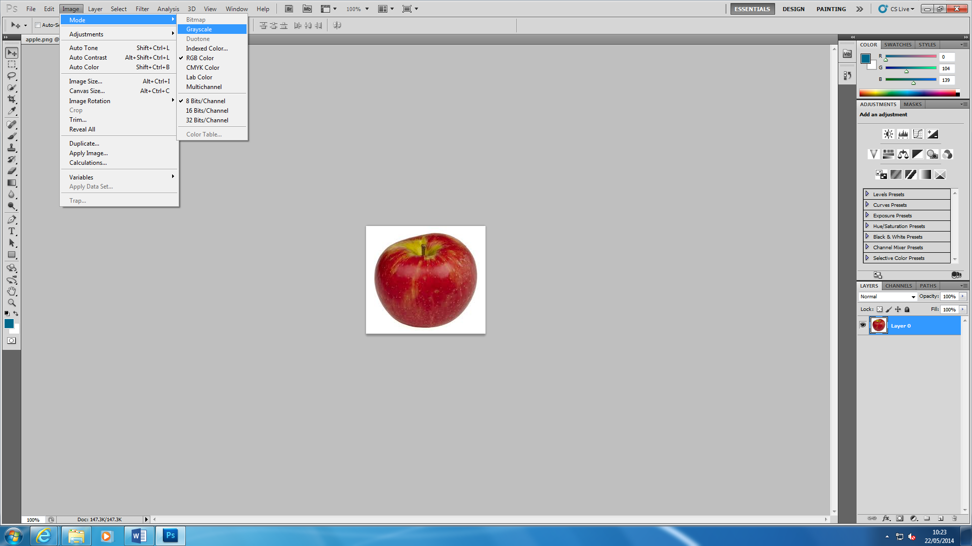

This demonstrates how to change the bits on each image. Each of the image show how many colours you can use. You can ‘Auto Colour’ and it adds more colour to the image. The image below shoes the result of what happens. It detects the bits once you open the image up.

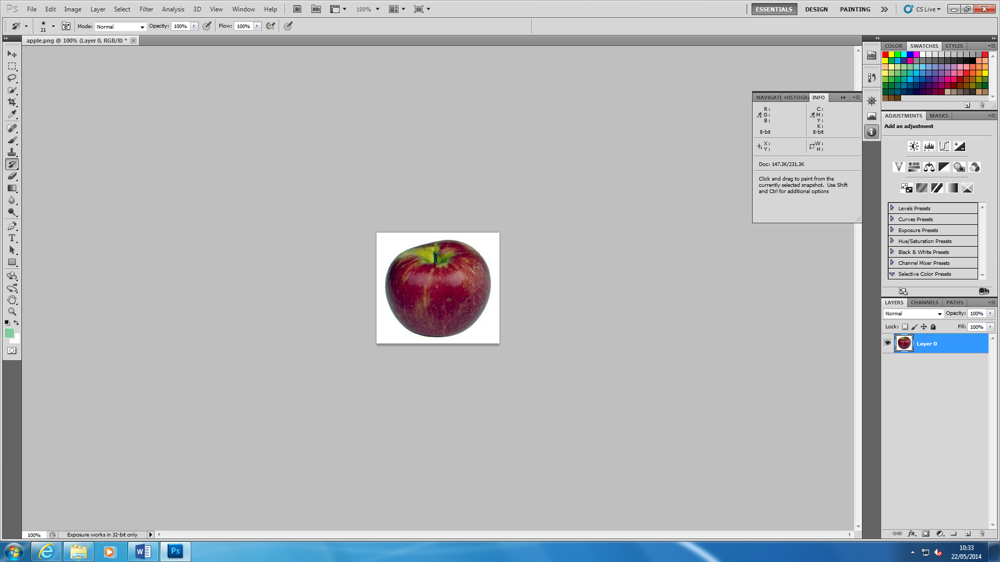

The file size of the colour depth